SQL Server Installation

1. Download the setup file from below link

SQL Server: <https://go.microsoft.com/fwlink/?linkid=866662>

1. Double click on the downloaded file to install the SQL database

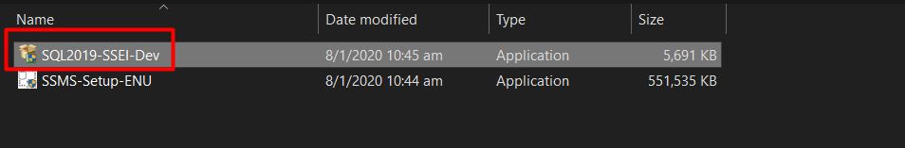

1. Select Basic type

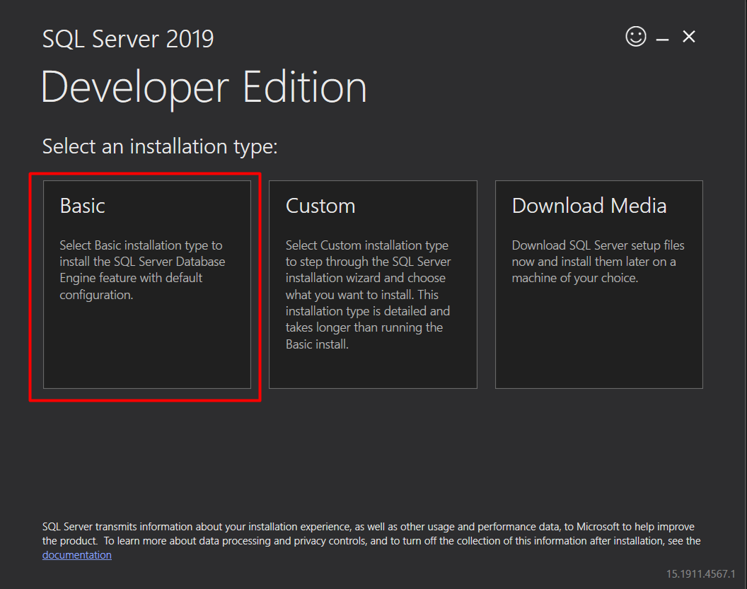

1. Accept the license and select the default installation path in next page.

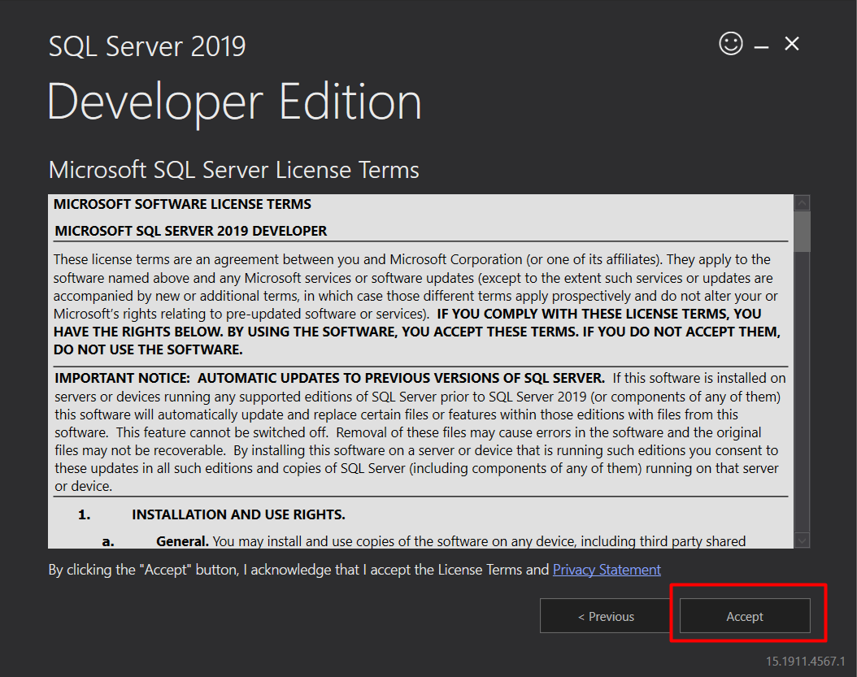

1. Installation is in progress…

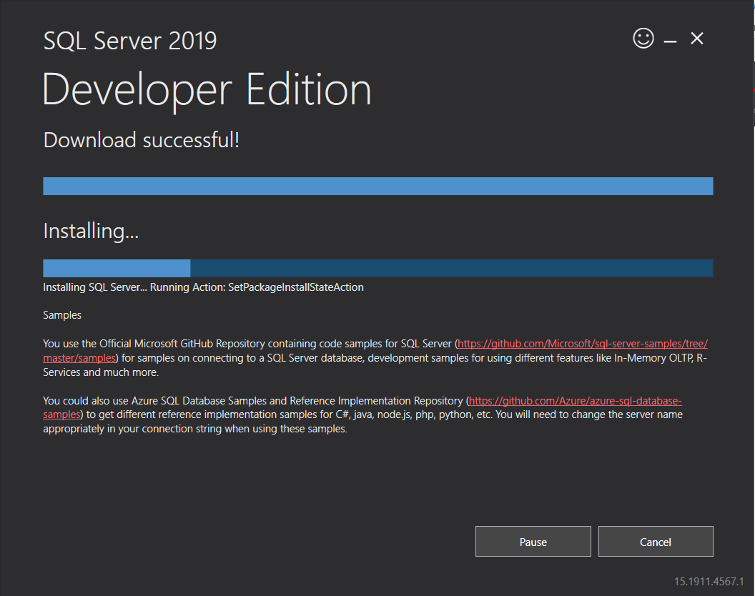

1. Once complete. Close the window

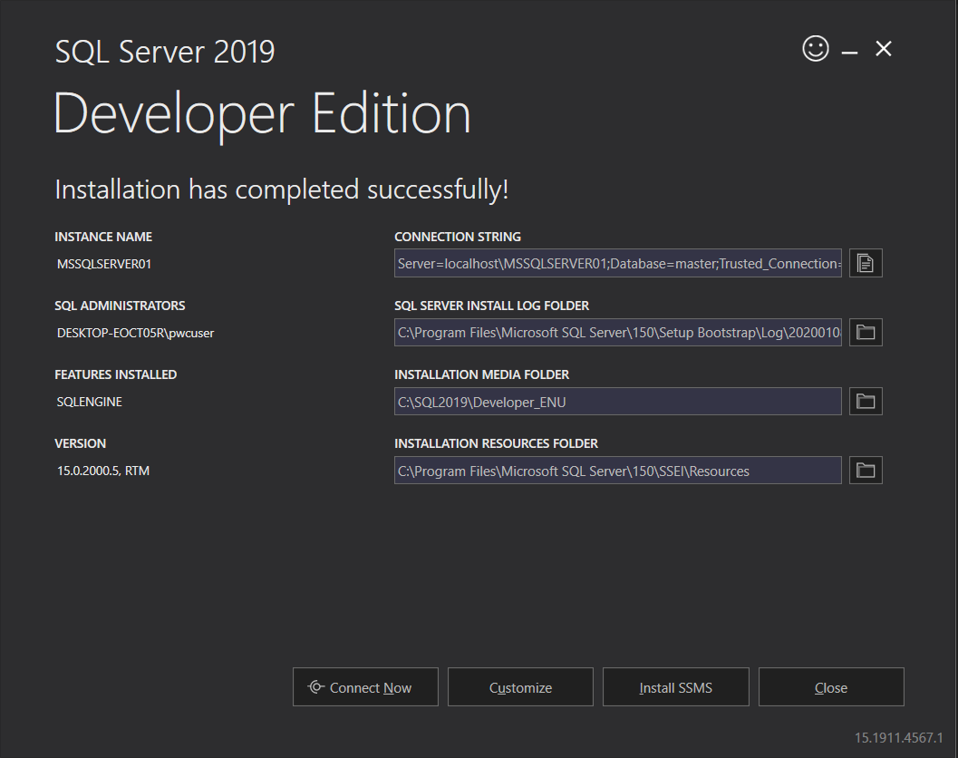

Install SSMS

1. Download SSMS package from below link

SSMS: <https://aka.ms/ssmsfullsetup>

1. Double click on the downloaded file to install SSMS

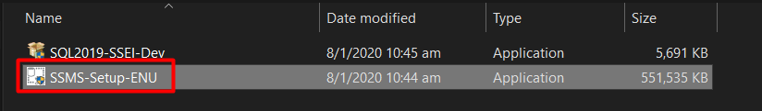

1. Click on install.

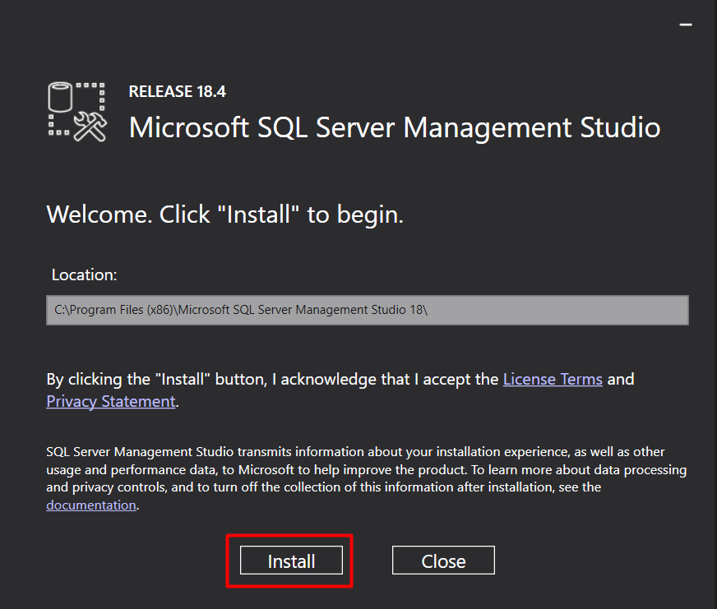

1. Installation in progress and close the window once complete.

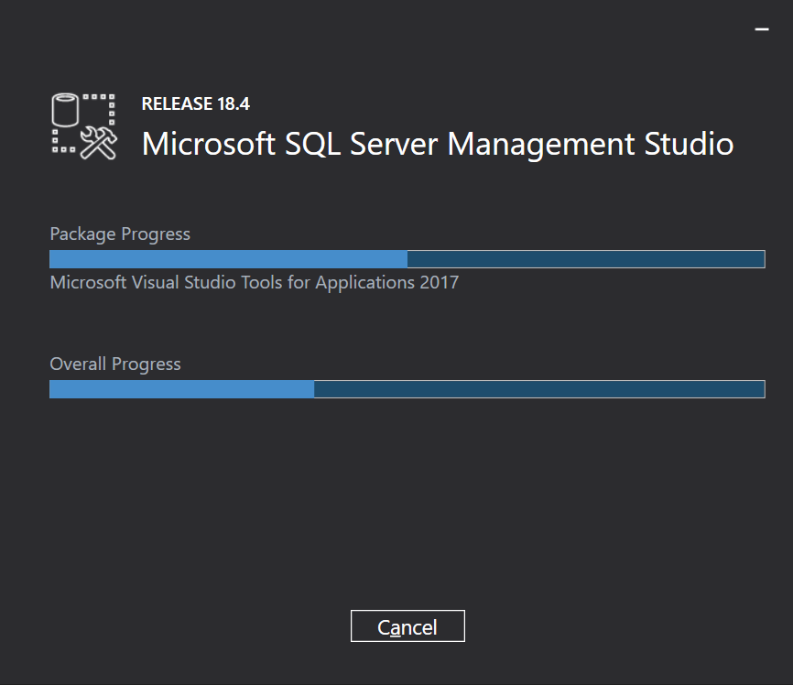

Connecting to SQL server using SSMS

1. Search in window task bar for “SSMS” and select SSMS 18 .

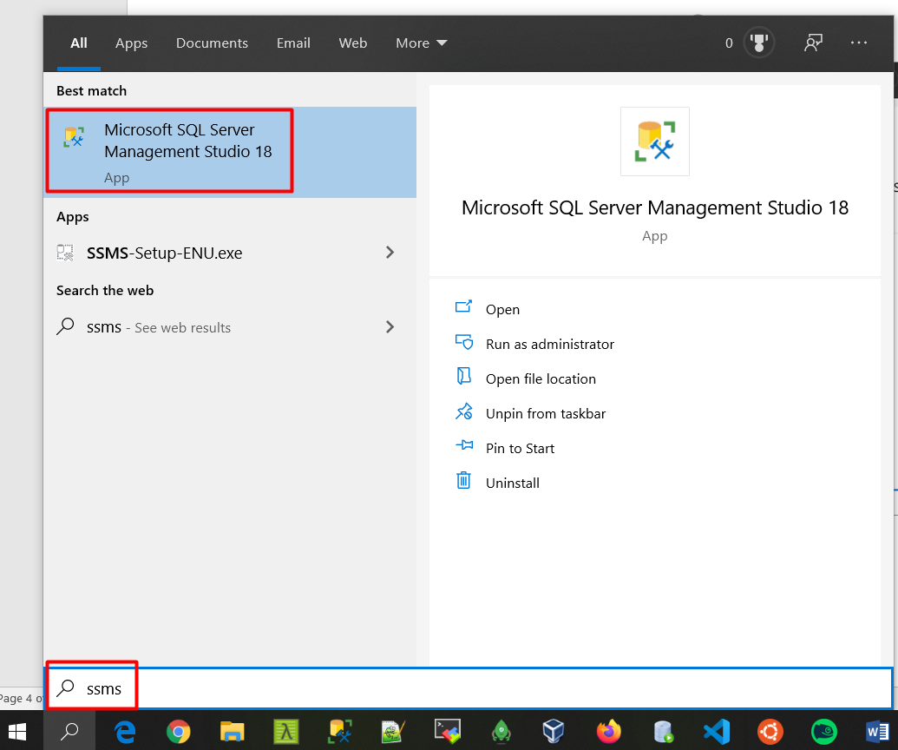

1. Check server name which will be your computer name and rest leave it as default and click connect. If you face any issue, please check with you instructor.

